**HCL Commerce Personalization Demo #1 – SoFy Environment**

Some introduction and details go here

**Step 1 - Review Current Website Content**

1. Open up Emerald Storefront from the SoFy Solution Console link
2. Review the home hero image and recommend products currently displayed
3. Click on any recommended product
4. Add to cart > View full cart
5. Click on Emerald icon in top right of page
6. Notice that the home hero image and product recommendations are unchanged

**Step 2 - Create New Home Hero Content**

1. Open Management Center from the SoFy Solution Console link
2. Menu > Workspace Management > File > Work on Approved Content
3. Menu > Marketing
4. Verify store showing right side drop down is EmeraldSAS
   1. If not, select EmeraldSAS from drop-down menu
5. Select Content from left menu list
6. Select HomeHeroContent
   1. Edit > Copy
   2. Edit > Paste
7. Modify new content
   1. Name: HomeHeroContent-Bedroom
   2. Text: <div class="MuiGrid-root MuiGrid-container marketing-content marketing-backgroundImage marketing-heroImage KitchenHeroContent"><img src="/EmeraldSAS/images/rooms/bedroom.jpg"><div class="MuiGrid-root MuiGrid-item MuiGrid-grid-xs-10 MuiGrid-grid-md-6 MuiGrid-grid-lg-5 marketing-text marketing-text-vertical-center"><h2 class="MuiTypography-root MuiTypography-h2 bottom-margin-1"><b>Explore Your New Bedroom</b></h2><h5 class="MuiTypography-root MuiTypography-h5 bottom-margin-2">Sleep in luxury with all new furniture, lighting, and decor that fit any bedroom style.</h5><a href="/bedroom"><button class="marketing-button primary" tabindex="0" type="text"><span class="MuiButton-label">Shop Bedroom</span><span class="MuiTouchRipple-root"></span></button></a></div></div>
   3. URL: /bedroom
8. Save > Close

**Step 3 - Create Home Hero Web Activity**

1. Select Activities from left menu list
2. File > New > Web Activity > Content Recommendation > OK
3. Select Starting Point on workspace
   1. Name: Home Hero Image

1. Select E-Marketing Spot on workspace
   1. Enter “*” in search box and click ‘Find and Add”
   2. From list on right, drag over “Home Hero” to the selection area

1. Select Recommended Content on workspace
   1. Enter “*” in search box and click ‘Find and Add”
   2. From list on right, drag over “HomeHeroContent” to the selection area

1. Drag Branch icon from tool panel to area between E-Marketing Spot and Recommended Content

1. Select Branch on workspace
   1. Name: Home Hero Personalization
   2. Paths: Bedroom, General

1. Select Recommend Content from Bedroom Branch on workspace
   1. Click on HomeHeroContent listed in the Content box and click the “X” next to the ‘Find and Add” button to remove it
   2. Enter “*” in search box and click ‘Find and Add”
   3. From list on right, drag over “HomeHeroContent” to the selection area

1. Drag Cart icon from tool panel to the Bedroom branch right before the Recommended Content icon

1. Select Cart from Bedroom Branch on workspace
   1. Shopping Cart Contents: Catalog Entries from Specific Categories
   2. Target Customers: Who have catalog entries from any of the following categories and satisfy the following conditions
   3. Categories
      1. Enter “*” in search box and click ‘Find and Add”
      2. From list on right, drag over “Beds” and “Dressers” to the selection area
   4. Save
   5. Edit > Activate
   6. Close

**Step 5 - Modify Home Hero Web Activity**

1. Select Activities from left menu list
2. Select “Home Recommended products”
3. Edit > Deactivate
4. Double click on “Home recommended products” to open activity
5. Drag Branch icon from tool panel to area between E-Marketing Spot and Recommended Catalog Entry

1. Select Branch on workspace
   1. Name: Home Hero Personalization
   2. Paths: Bedroom, General

1. Drag Cart icon from tool panel to the Bedroom branch right before the Recommended Catalog Entry icon

1. Select Cart from Bedroom Branch on workspace
   1. Shopping Cart Contents: Catalog Entries from Specific Categories
   2. Target Customers: Who have catalog entries from any of the following categories and satisfy the following conditions
   3. Categories
      1. Enter “*” in search box and click ‘Find and Add”
      2. From list on right, drag over “Beds” and “Dressers” to the selection area

1. Select Recommend Catalog Entry from Bedroom Branch on workspace
   1. Select all entries listed in the catalog entries box
   2. Click the “X” next to the ‘Find and Add” button to remove it

1. Add Bedroom products
   1. Within the search box, enter and add the following products
      1. BD-BEDS-0001
      2. BD-BEDS-0004
      3. BD-DRSS-0003
      4. BD-DRSS-0002
      5. BD-BEDS-0003
   2. Save
   3. Edit > Activate
   4. Close

**Step 6 - Review Website Personalization**

1. Open up Emerald Storefront from the browser tab or from the SoFy Solution Console link
2. Review the current home hero image and recommended products
3. Go to Bedroom > Dressers
4. Select any item
5. Add to cart > View full cart
6. Return to Home Page and review changes to the Home Hero and Recommended Products

**Step 7 – Demonstrate API Capabilities**

1. Open Postman
2. Import Environment JSON into the workspace
   1. Select Environments > Import
   2. Click “Upload Files” and select the “HCL Commerce SoFy Demo 1 - Environment.json” or drag file into the window
   3. Click Import

1. Update “bda-hostname” variable
   1. Click on “HCL Commerce SoFy Demo 1 Environment”
   2. Update the current value of “bda-hostname” by replacing the * values with the number shown on your SoFy Solutions Console
   3. Click Persist All
   4. Click Save

1. Import API Collection into the workspace
   1. Select Collections > Import
   2. Click “Upload Files” and select the “HCL Commerce SoFy Demo 1 - API Collection.json” or drag file into the window
   3. Click Import

1. Run API Collection
   1. From the collections area, click “HCL Commerce SoFy Demo 1 - Personalized Shopping Experience” to expand APIs
   2. On the right side, click on “No Environment” and select “HCL Commerce Sofy Demo 1 Environment” from the dropdown menu

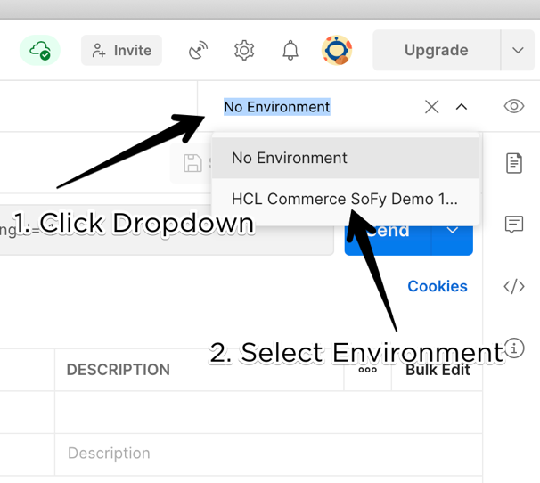

* 1. Select “Begin Guest Shopper Session” API > Click “Send” > Verify results
     1. Call will return data to confirm a session has been established

* 1. Select “GET Default E-marketing Spot Data” API > Click “Send” > Verify results
     1. Call will return a listing of the default recommend products shown on the home page

* 1. Select “Add Qualifying Item to Cart” API > Click “Send” > Verify results
     1. Call will return data confirming that an item has been added to the cart

* 1. Select “GET Personalized E-marketing Spot Data” API > Click “Send” > Verify results
     1. Call will return a listing of the personalized recommend products shown on the home page when an item from a bedroom subcategory is in the cart

